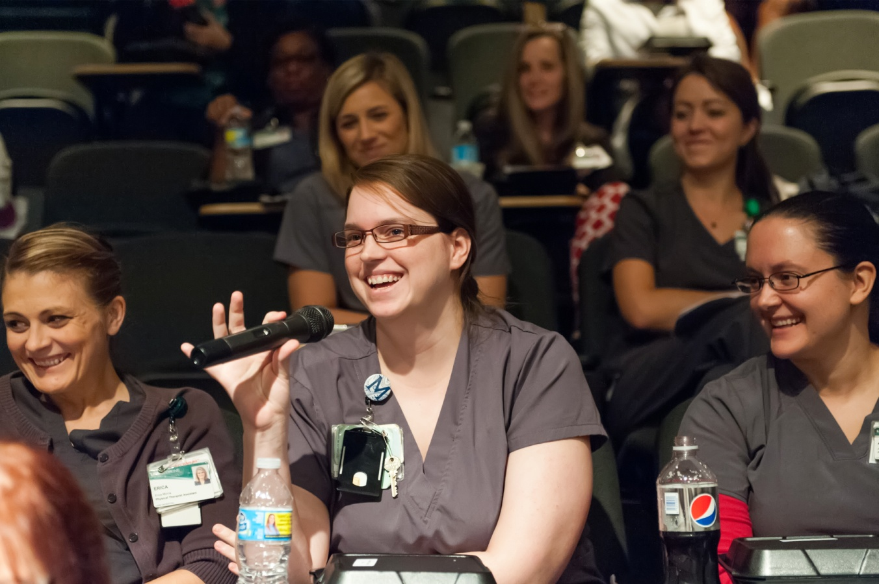

Lunch will be served.

Open to all [organization name] employees, affiliated clinicians and trainees.

**Panelists:**

Panelist 1

Panelist 2

Panelist 3

Schwartz Rounds program is a multidisciplinary forum where

clinical caregivers can discuss social and emotional issues that arise in caring for patients.

For more information, please contact [name] at [email/phone].

**“Title of session”**

**Date**

Time

Location

**Schwartz Rounds™ Program**

[organization logo]

**This program is provided with support from:**